LIBRARY MANAGEMENT SYSTEM

IN SQL
*Display all books.
*SELECT * FROM books;

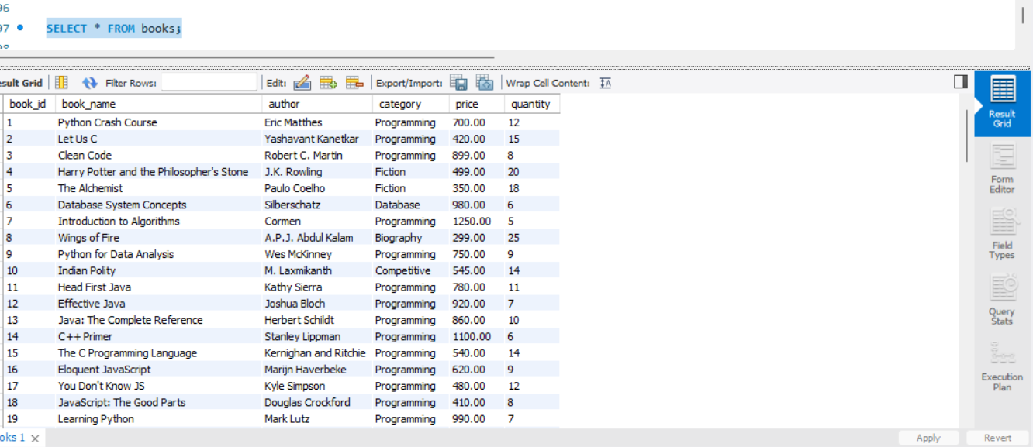
*Display all students.
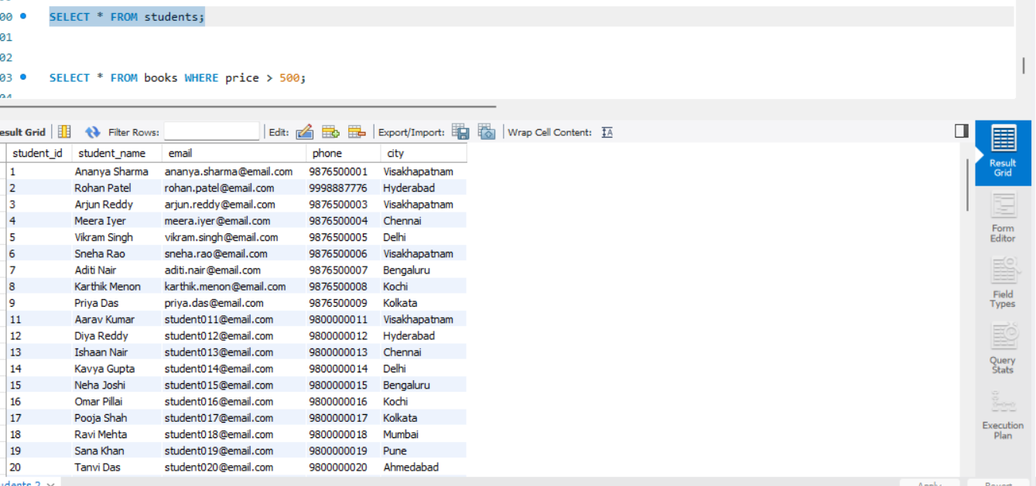

*Display books with price greater than ₹500.

*Display books belonging to the `Programming` category. 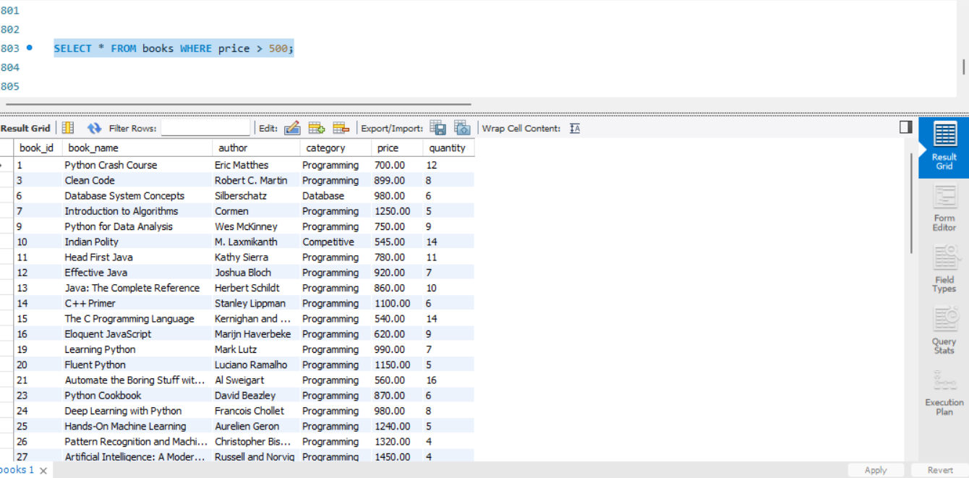

*Display students from `Visakhapatnam`.
- 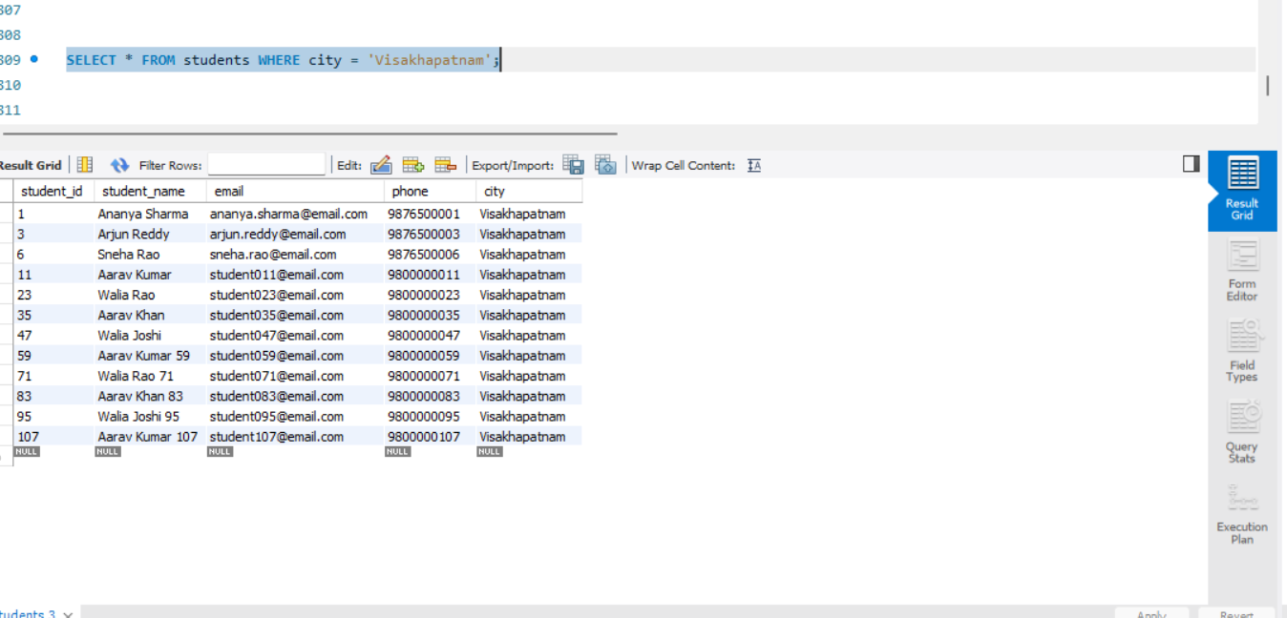

*Display books in ascending order of price. 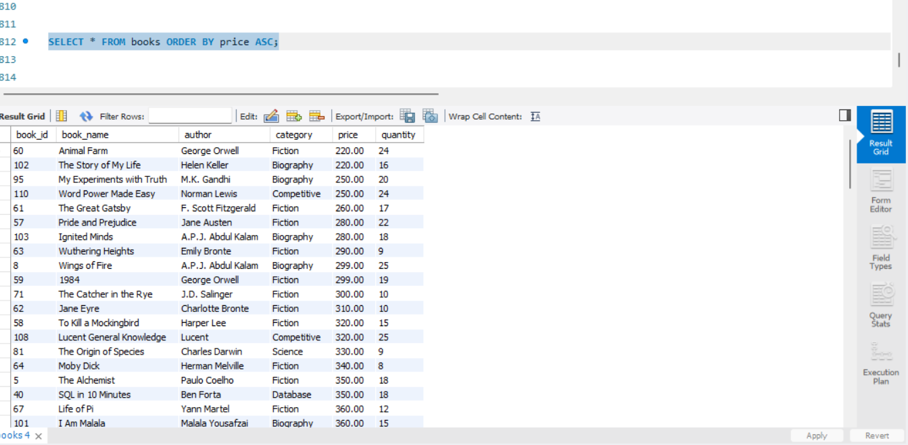

*Display books in descending order of price. 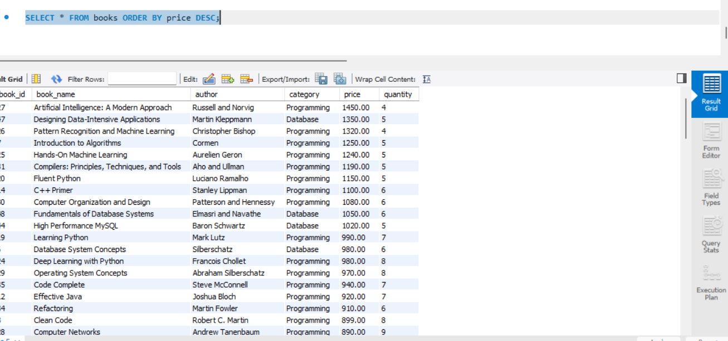

* Find the total number, average price, highest book price and lowest book price of the books. 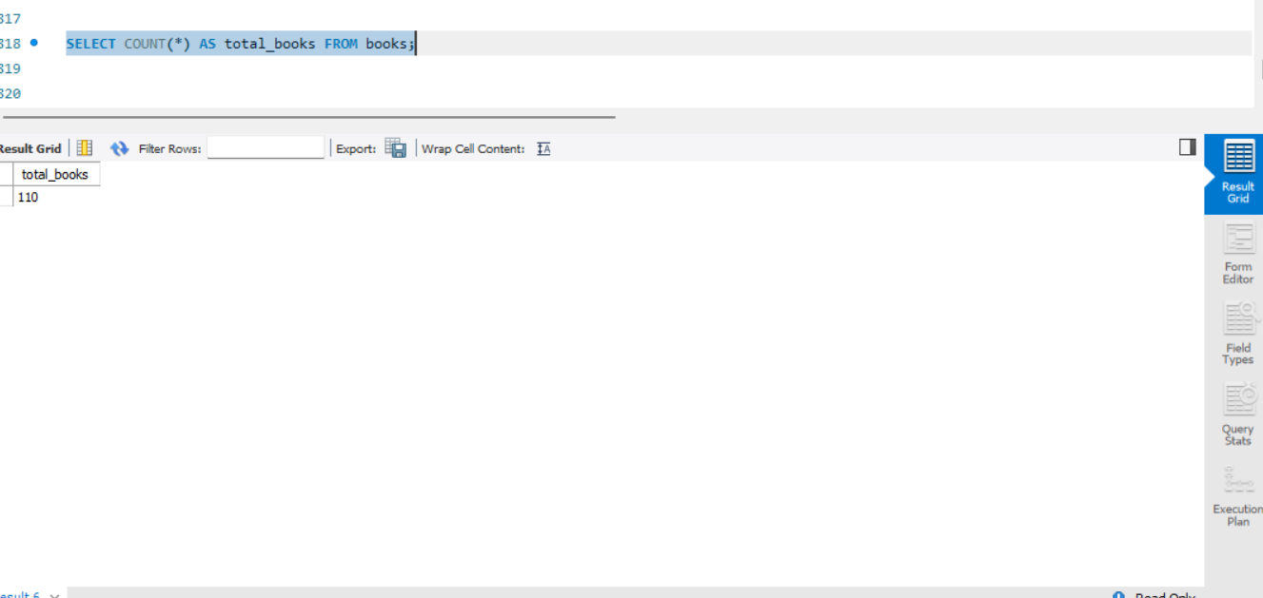
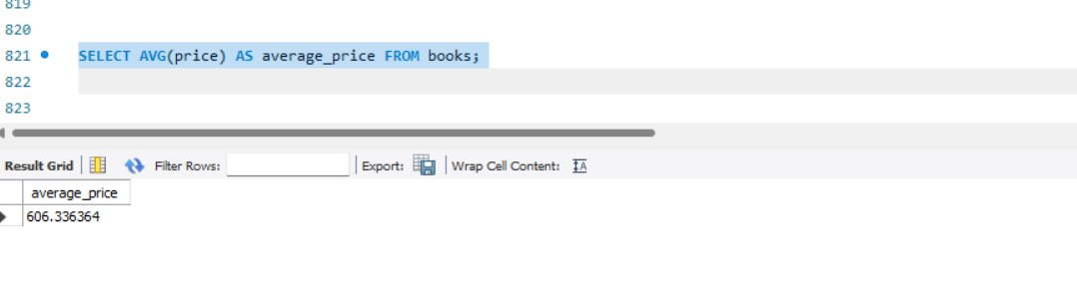
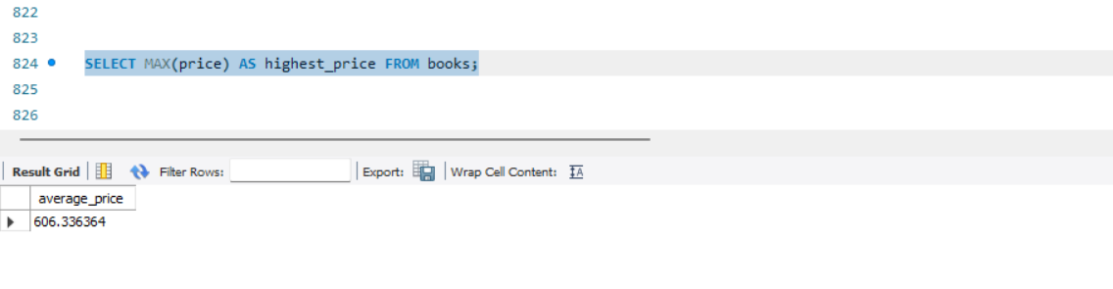
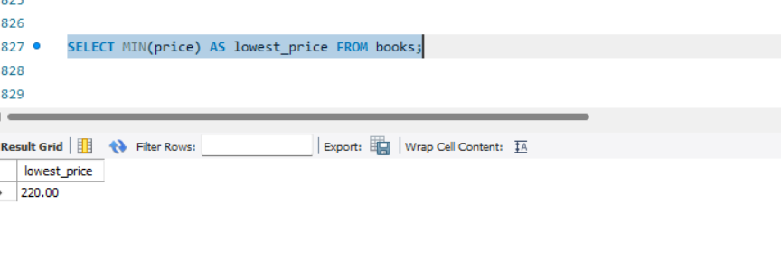
*Display students whose names start with `A`. 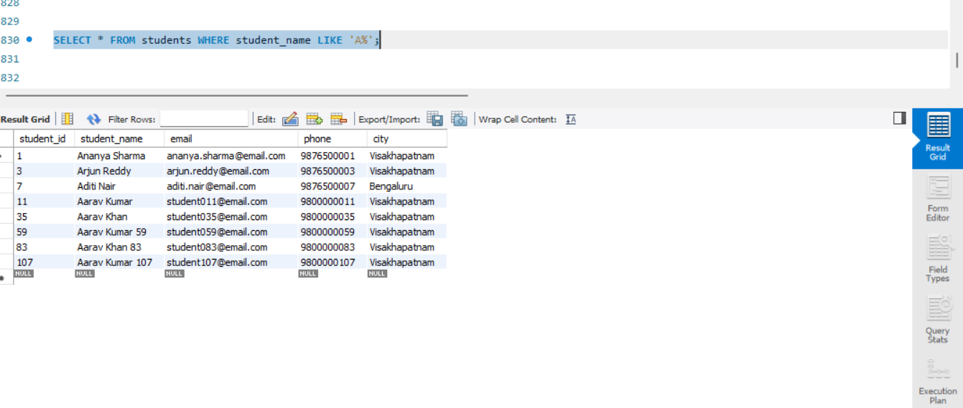

* Display books whose names contain `Python`. 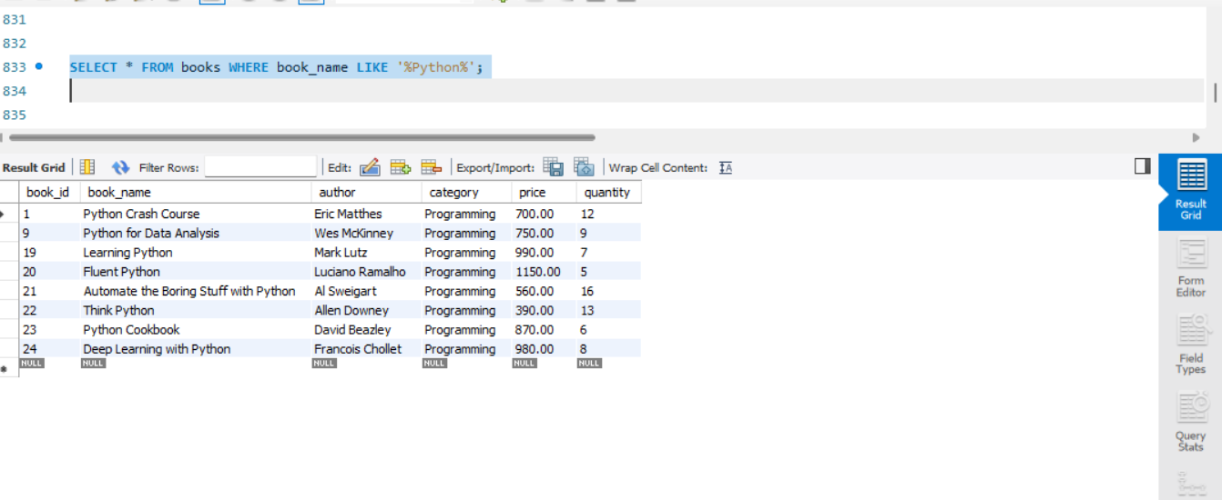

* Update the price of a book.
UPDATE books SET price = 700.00
WHERE book_id = 1 AND book_name = 'Python Crash Course';
Before update
After Update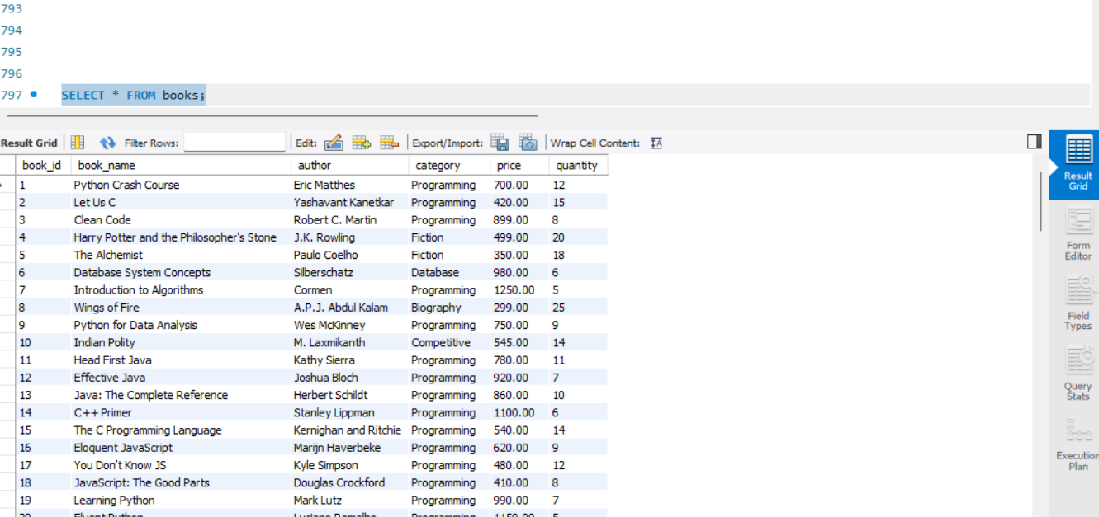

* Update a student's phone number.
UPDATE students SET phone = '9998887786'
WHERE student_id = 2 AND student_name = 'Rohan Patel'
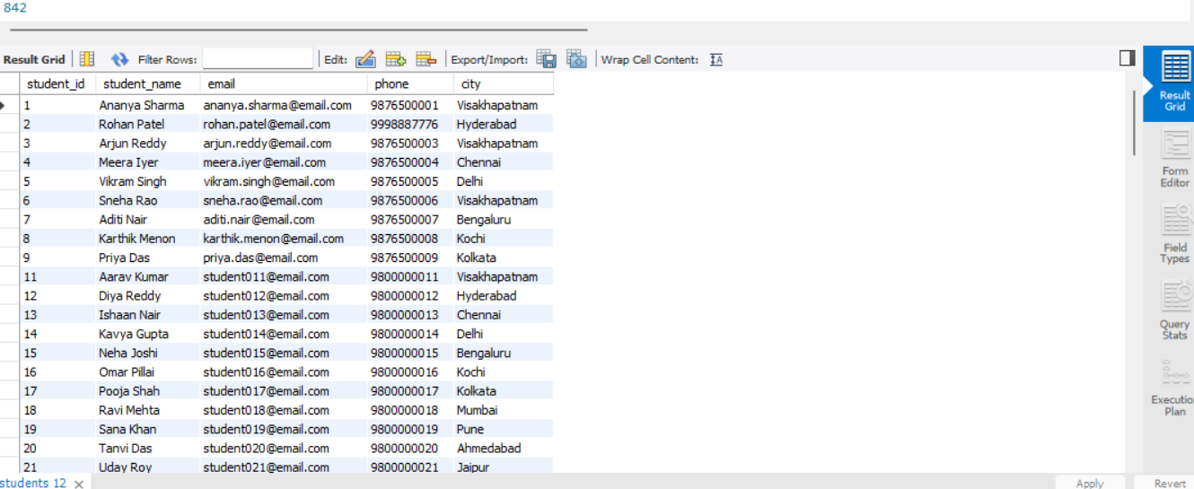
Before update

After Update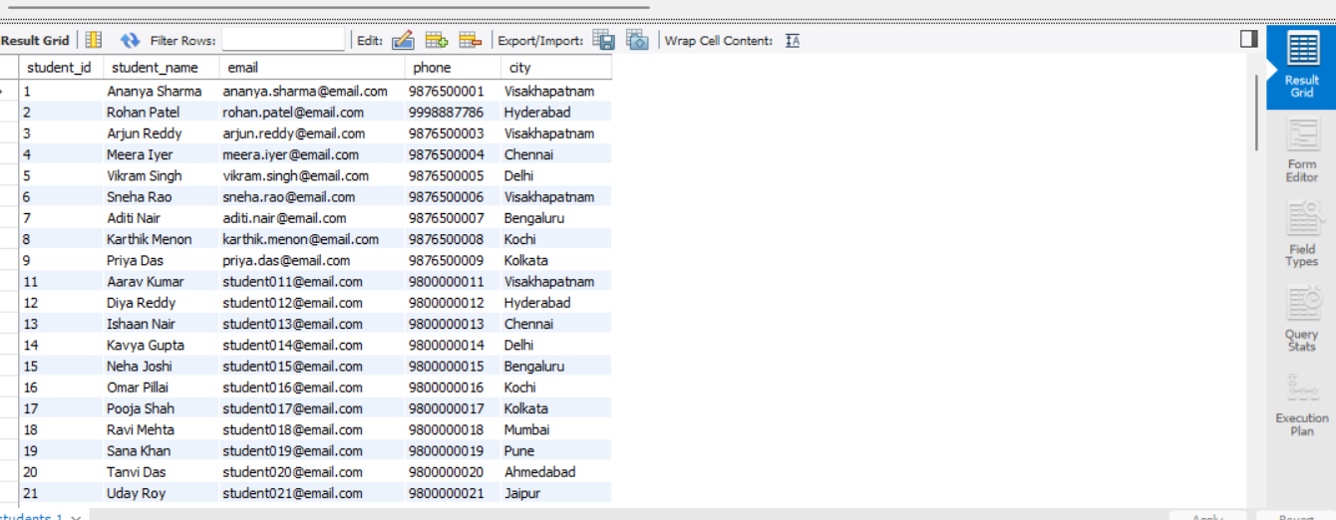
* Delete one student record
DELETE FROM students WHERE student_id = 10 AND student_name 'Rahul Verma';
Before Delete:
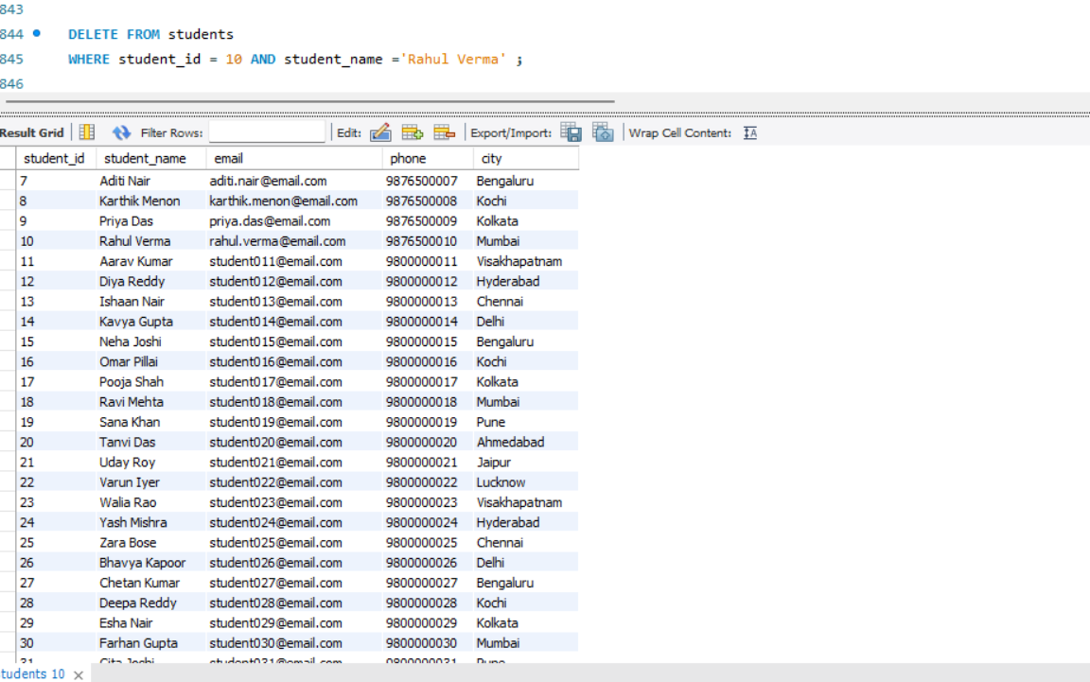

After Delete:
17. Display issued book details. 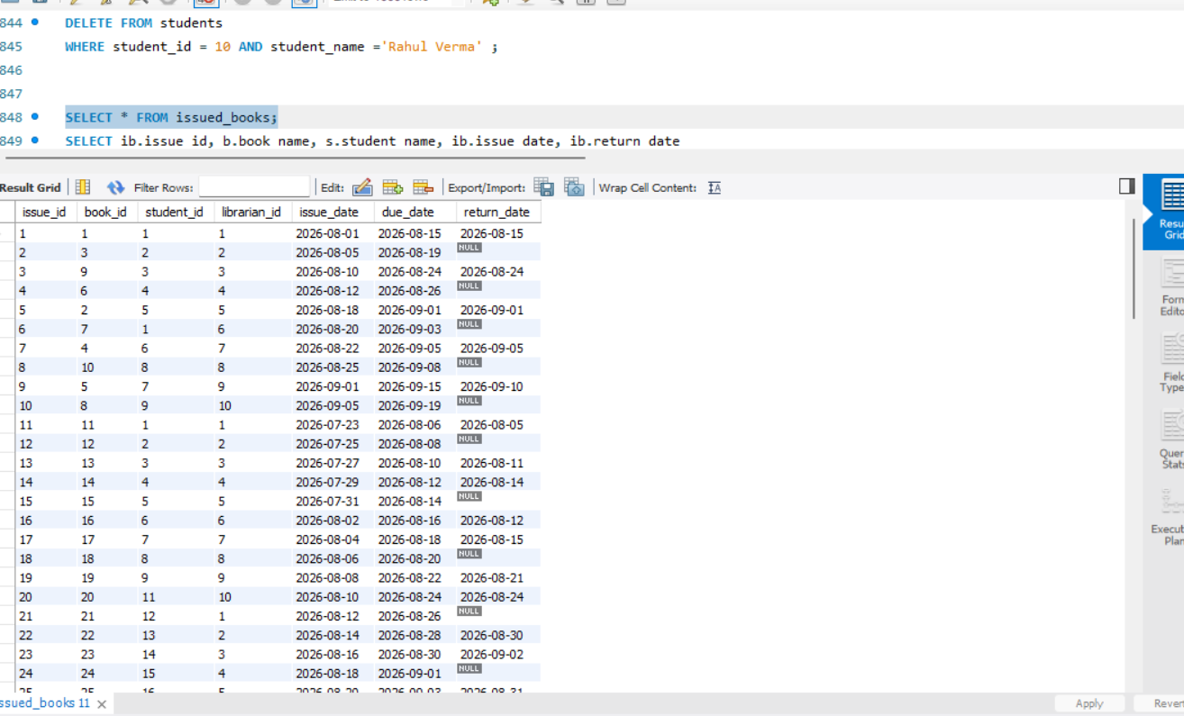

* Display books that are currently not returned.
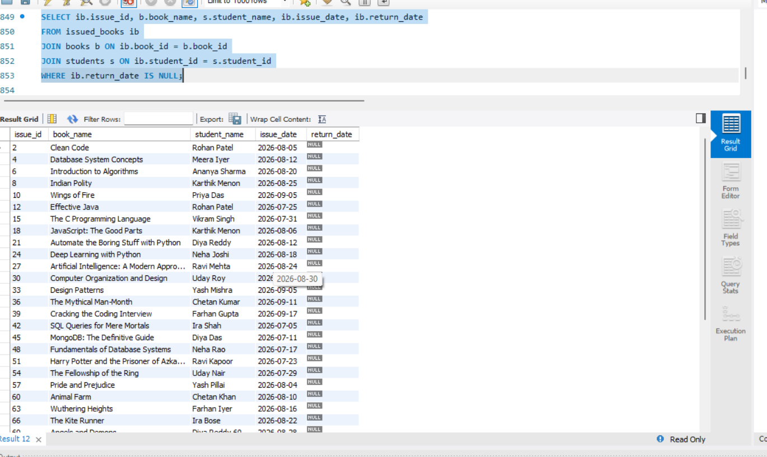

* Count the number of issued books
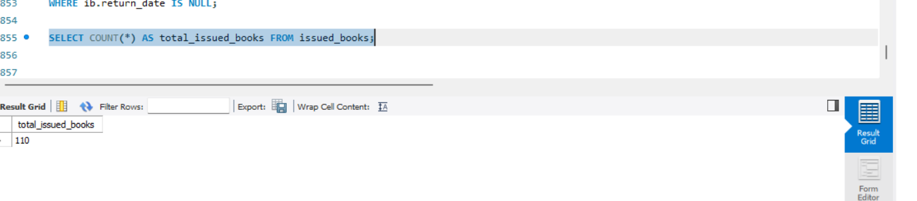

* Display book details along with the student who issued them using a JOIN.

